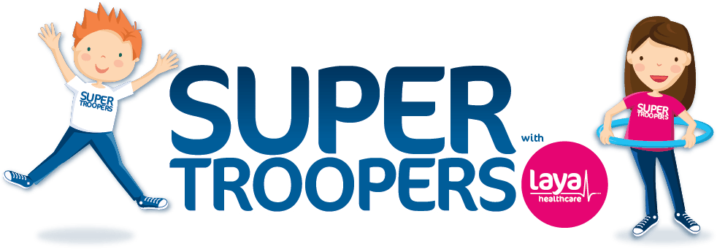

Cullina N.S. is very excited to welcome Super Troopers with Laya Healthcare, the first ever health homework programme in Ireland. It encourages children and their families to become more active and learn about healthy lifestyles. The programme includes short burst, fun activities around physical activity, wellbeing and nutrition. A healthy mind is just as important as a healthy body which is why we’ve introduced even more fun wellbeing activities and introduced SuperValu as the official healthy eating partner to Super Troopers.

Did you know that only one in five Irish children currently meet the World Health Organisation (WHO) recommended daily guidelines of 60 minutes of activity per day?

Laya Healthcare has created this exciting and FREE programme along with teachers and a team of experts in the areas of psychology, nutrition, wellbeing and physical activity to encourage YOU to get more active!

Watch this space for lots of exciting news and photographs to follow.........